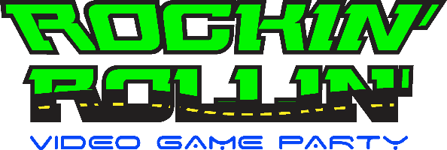

We bring our Luxury, Limo-style Theater on Wheels to YOU! It’s Multi-Player Gaming at its best!

- 2 Outside Gaming/Action Stations!
Book online now!
www.RockinRollinVideoGameParty.com 910-977-2228
910-690-5215

- 8 HD Widescreen TVs!
- 5 Xbox One S! 2 Wii U’s!
- Nintendo Switch!
- 4 PS4’s!! Laser Light Show!
- NEW Virtual Reality Station!
- {Virtual Reality age 10 and up)!
Follow us on
- 30 Gamers at the same time!

Perfect for:
Weekend Rates:
$339.00 for 2 Hours
$99.00 Add 1 Hour
Weekday Rates:
$309.00 for 2 Hours
$99.00 Add 1Hour
Combo Rates:
3 Hours - 90 minutes of each $539
3 Hours Non-Stop - Game Truck & Laser Tag $639

- Birthday Parties
- School & Charity Events
- Fundraisers * Graduations
- Tailgating Parties
- Corporate Picnics / Parties
- Sales Events
- Customer Appreciations
- Fall/Spring Festivals
- Family Reunions
- Neighborhood Parties
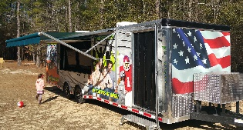
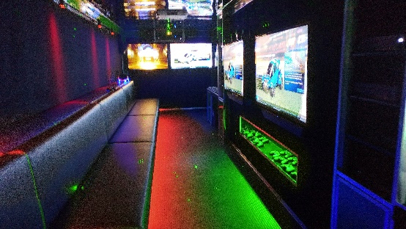
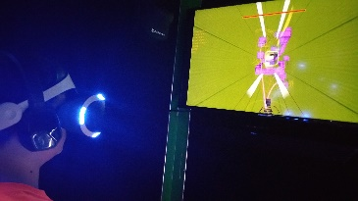
Call for special event pricing!

$20 FUNDRAISING CASH BACK TO REFERRING
SCHOOL, NON-PROFIT OR CHURCH!
sales@rockinrollinvideogameparty.com

