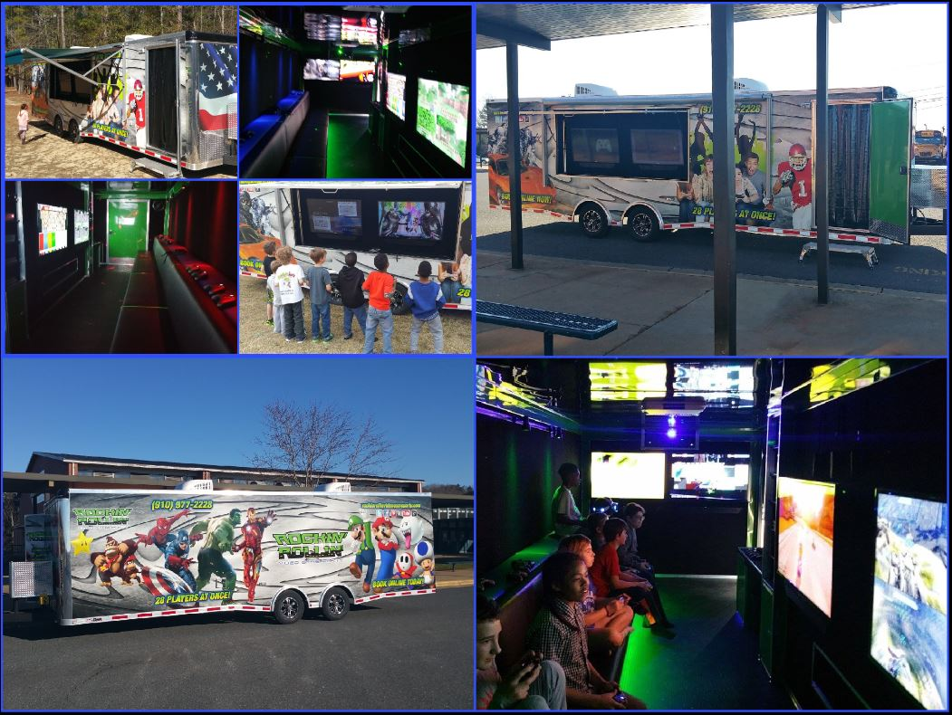

**Date/Time:**

**Place:**

**RSVP to:**

You’re invited to a Mobile Video Game Party!

In Honor Of: