We bring our Luxury, Limo-style Theater on Wheels to YOU! It’s Multi-Player Gaming at its best!

- 2 Outside Gaming/Action Stations!
Book online now!
www.RockinRollinVideoGameParty.com 910-977-2228
910-690-5215

- 8 HD Widescreen TVs!
- 5 Xbox One S! 2 Wii U’s!
- 4 PS4’s!! Laser Light Show!
- NEW Virtual Reality Station!
- {Virtual Reality age 10 and up)!
Like us on
- 30 Gamers at the same time!

Perfect for:
- Birthday Parties
Weekend Rates:
$339.00 for 2 Hours
$99.00 Add 1 Hour
Weekday Rates: $309.00 for 2 Hours
$99.00 Add 1Hour
Combo Rates: 3 Hours - 90 minutes of each $539
3 Hours Non-Stop - Game Truck & Laser Tag $639

- School & Charity Events
- Fundraisers * Graduations
- Tailgating Parties
- Corporate Picnics / Parties
- Sales Events
- Customer Appreciations
- Fall/Spring Festivals
- Family Reunions
- Neighborhood Parties
Call for special event pricing!

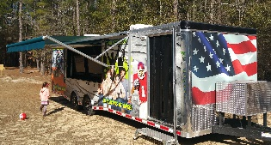
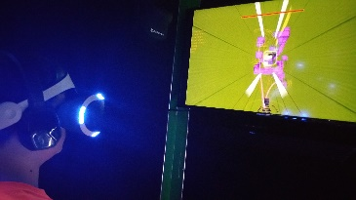
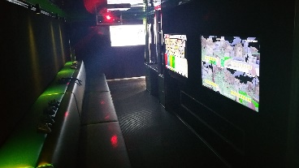
$20 FUNDRAISING CASH BACK TO REFERRING
SCHOOL, NON-PROFIT OR CHURCH!
sales@rockinrollinvideogameparty.com

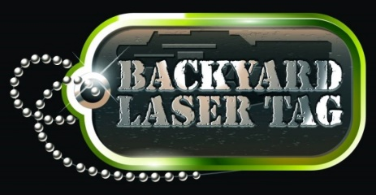
Mobile Laser Tag! Play Inside or Outside!
We Bring the Party to You!

Book online now!
backyardlasertagparty.com
910-977-2228
910-690-5215

- Up to 14 “Recruits” can play at a time!
- Camouflage Face Paint/Tactical Vests!
- Pop up Bunkers – Re-Spawn Stations
- Mobile Unit has Seating & Heat/Air
- Red and Blue Light Weight Taggers!
Like us on
Perfect for:
- Birthday Parties
- School & Charity Events
Weekend Rates:
$339.00 for 2 Hours
$99.00 Add 1 Hour
Weekday Rates: $309.00 for 2 Hours
$99.00 Add 1Hour
Combo Rates: 3 Hours - 90 minutes of each $539
3 Hours Non-Stop - Game Truck & Laser Tag $639
3 Hours Non-Stop - Game Truck & Laser Tag $639
3 Hours Non-Stop - Game Truck & Laser Tag $639

- Fundraisers * Graduations
- Team Building
- Corporate Picnics / Parties
- Sales Events
- Customer Appreciations
- Fall/Spring Festivals
- Family Reunions
- Neighborhood Parties
Call for special event pricing!

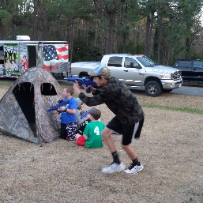
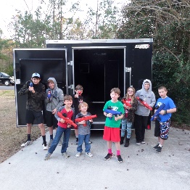
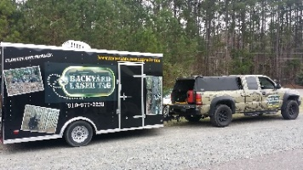
$20 FUNDRAISING CASH BACK TO REFERRING
SCHOOL, NON-PROFIT OR CHURCH!
sales@backyardlasertag.com

